Data Cleaning and Anal(ytics)
Data cleaning involves handling missing values, duplicate data and outliers in order to prepare the data for analysis.
Data analytics involves classifying, visualising and interpreting the data

Data Quality:
Criteria: Validity, Accuracy, Completeness, Consistency, Uniformity
Validity – the degree to which the data conforms to defined rules or constraints, e.g. datatype constraints, mandatory constraints, regex patterns etc.

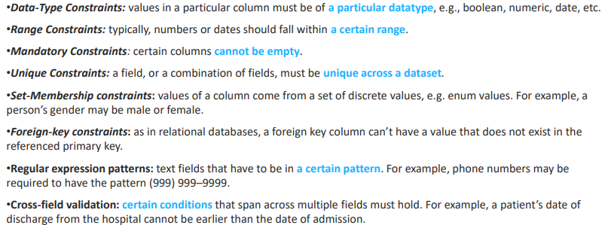
Accuracy – the degree of conformity of a measure to a standard or true value.
Just because data is valid doesn’t mean it exists.
Accuracy is very hard to achieve through data cleansing since we need a source of true data to confirm the accuracy.
Just because data is precise doesn’t mean it is accurate

Completeness – the degree to which all required measures are known
Incompleteness is basically impossible to fix with data cleansing, since facts cannot be inferred if they were not captured in the data. Default values indicating “unknown” can be added but these do not imply the data is complete.
Consistency – the degree to which the data is consistent, i.e. within the same dataset or consistent with other datasets.
Inconsistency occurs when two data items contradict each other. Fixing these inconsistencies is not always possible, but we can e.g. assume the most recent record to be correct and remove the older data items.
Uniformity – the degree to which the data is specified using the same measurement units. Data from multiple datasets can use different units (e.g. metric vs American shitty freedom units) and these must be converted to a single measure prior to analysis.

How to produce high-quality data?
- Inspection – detect incorrect/inconsistent data
- Cleaning – fixing and removing the anomalies
- Verify correctness of the cleaned data
- Reporting – a report about the changes made to the data and the quality of the cleaned data.

Inspection:
Data profiling – a summary of statistics about the data, helpful to give a general idea about the data quality, e.g. checking whether columns conform to the standards or patterns (validity) or if there is a large number of missing values (incompleteness).
Visualisation – Analysing and visualising data using mean, standard deviation, range etc can be used to detect unexpected or erroneous values
Cleaning:
Duplicates can often happen, these should be removed.
Type conversions should occur to ensure values are of the correct datatype
Standardisation to ensure data is put into the same standardised format, e.g. DD/MM/YYYY for dates
Scaling or Transformation: transforming the data so it fits to a specific scale, e.g. 0-1, which can make the data easier to visualise
Missing values: Use some kind of identifier to represent the missing value, e.g. NULL.
Outliers: any values more than 1.5*IQR away from Q1 or Q3 are outliers, however these should not be removed without good reason.

Verification: reinspecting the data to check that the rules and constraints still hold after cleaning

Reporting: logging violation, considering causes of errors and reporting on the quality of the cleaned data.

NumPy and Pandas:
NumPy = Numerical Python
- Adds goofy arrays that can work nicely with data collections. It is claimed that NumPy runs quicker than Python lists.

NumPy arrays:
- Indexes the same as python lists
- For 2D arrays, indexing is a lil different – arr[1,0] for np arrays vs arr[1][0] for Python lists – note we can still use the normal syntax but its apparently less efficient
Axis parameter:
- axis = 0 or axis = 1 -> one means rows the other means columns but this is inconsistent.
Concatenating bidimensional arrays:
- with axis = 0: append the rows of arr2 to the rows of arr1, i.e. add the rows of arr2 as new rows in arr1.
- with axis = 1: append the columns of arr1 to the columns of arr2, i.e. the number of rows stays the same but the number of columns of the result is the sum of the columns in arr1 and arr2.

Arrays with different numbers of columns can only be concatenated along axis 1; arrays with different numbers of rows can only be concatenated along axis 0.
Concatenating along axis 2 creates a third dimension to the array:
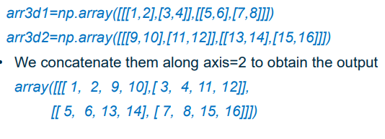
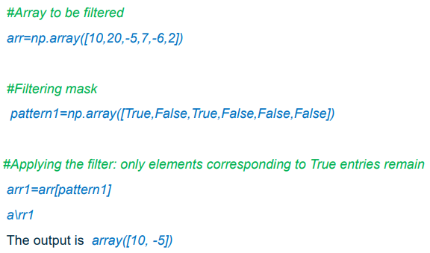
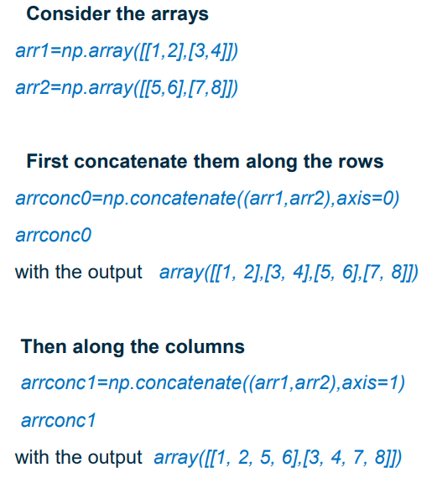
An np array of Booleans can be used to filter another np array:
We can create such Boolean patterns using conditions:
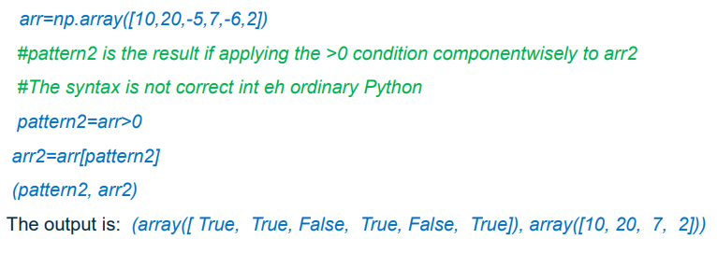
We can also combine patterns using “logical_and”, “logical_or”, “logical_not”:
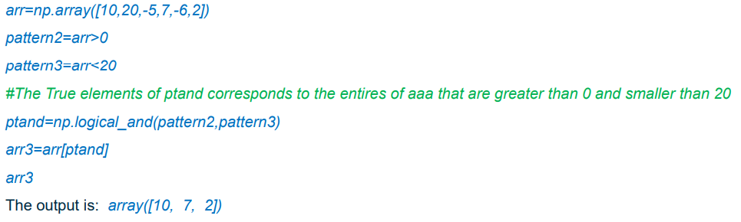
(bros spelling is atrocious)

Filtering 2D arrays (tables):
Np.any() -> if any value in the row/column is True, the corresponding output is true.
Np.all() -> if all values in the row/column are True, the corresponding output is True.
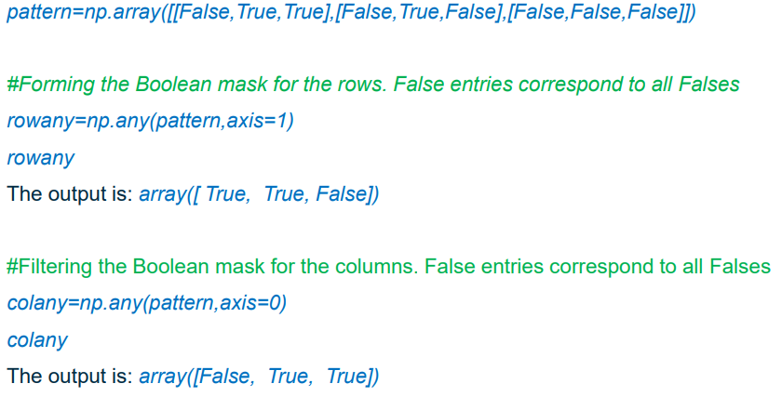
Use axis=1 to consider each row, axis=0 to consider each column:
^the first one checks each row for True entries, and returns True for each row with at least one True entry
The second one checks each column for True entries, and returns True for each column with at least one True entry.

Combining patterns and np.any():

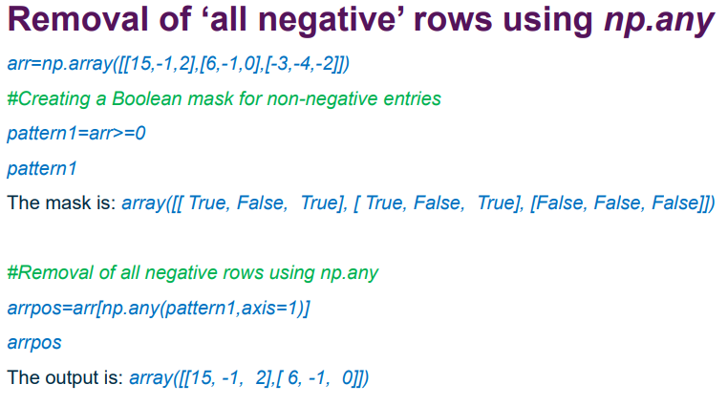
Filtering columns - np.delete() :
The construct making use of Boolean patterns to filter multidimensional arrays cannot be used to filter columns – use np.delete() instead.

Pandas:
Pandas uses DataFrames, which are data table thingies with numbered rows and named columns. DataFrames can be created from Python dicktionaries, where each key corresponds to a list – the keys representing column names and the lists representing the data for each column.
Example:

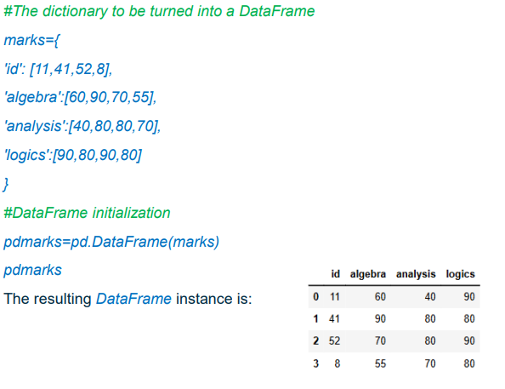
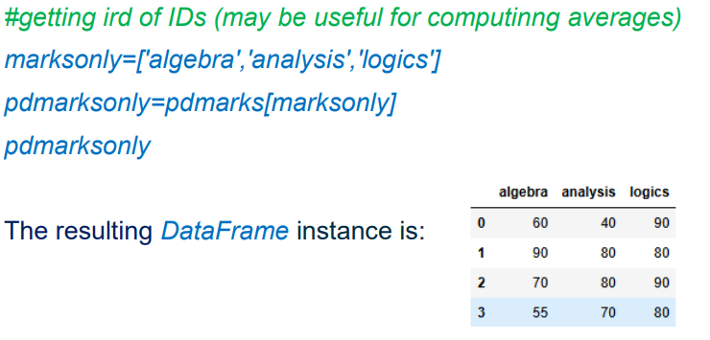
We can create a new DataFrame from an existing one, but with some columns removed, by passing in a list of column names that should remain in the new dataframe.
(jesus harold christ on a bicycle this guy cannot type for shit)
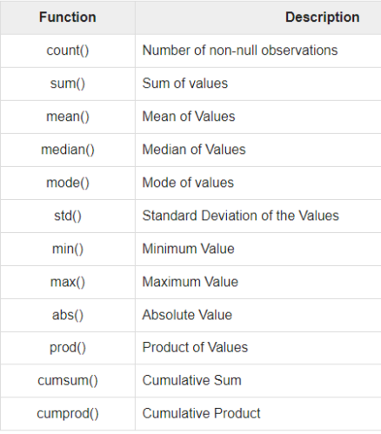
Stats in Pandas:
Mean computation:

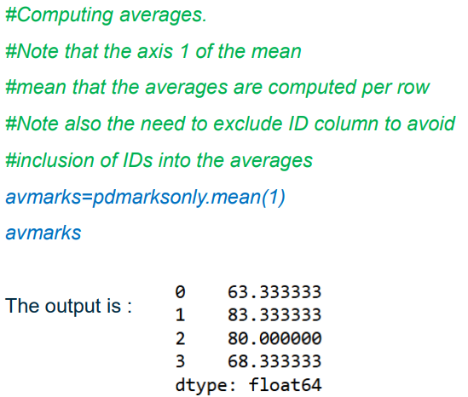
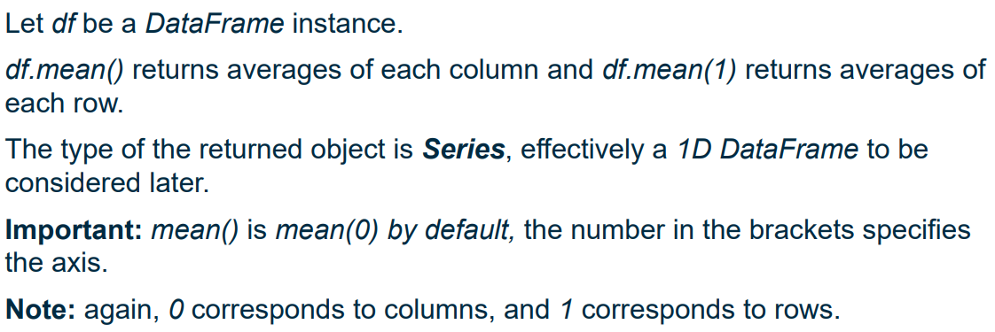
Adding a new column to a DataFrame:

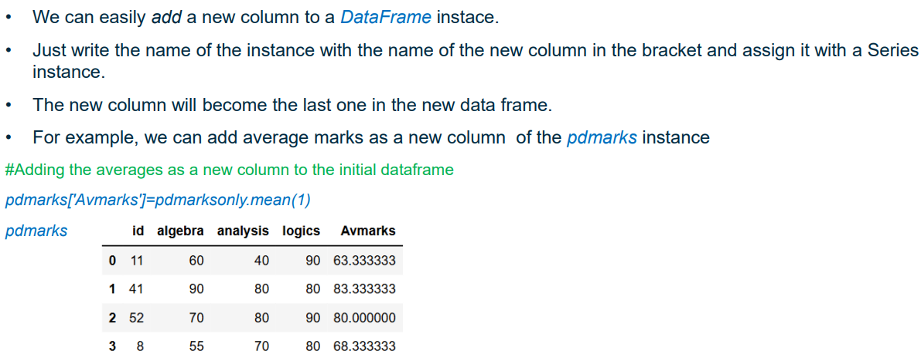
Sorting rows by values in a single column:
Apply sort_values() function, specifying column name. Is ascending by default, pass in “ascending=false” to do descending.
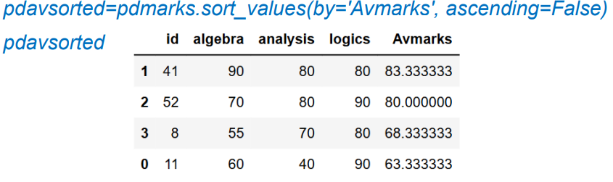
Columns and Index of DataFrames:
The names of the columns are stored in the “columns” attribute, the number of rows is stored in the “index” attribute. Both attributes are of type “Index”; if any of these attributes is an interval of integers, then the type is RangeIndex.
These attributes are immutable (i.e. column names cannot be directly modified), but can be accessed and printed.
Example:
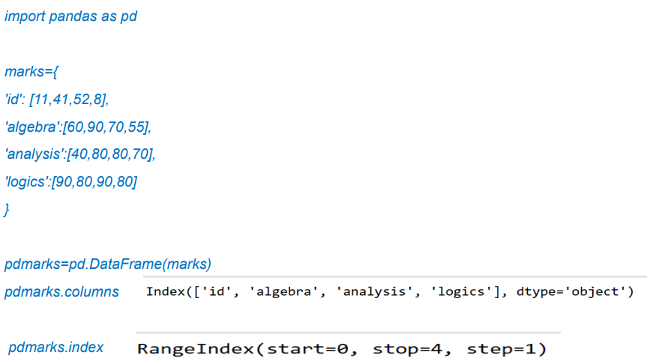
^note: stop=4 means last element is 3 – similar to how for loop ranges are funky.
We can use the columns attribute for column filtering:

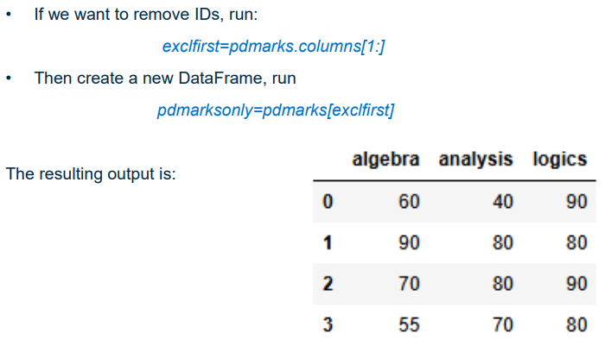
Example of changing column names and indices:
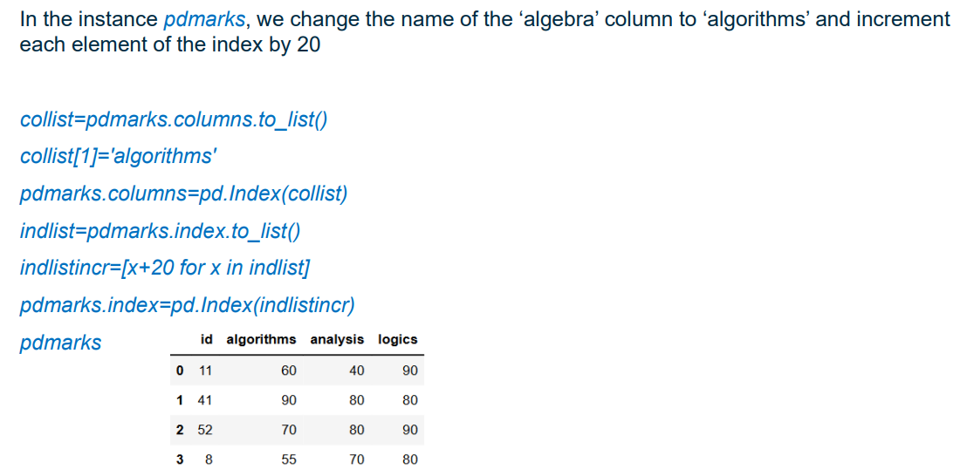
^index should be 20, 21, 22, 23 not 0,1,2,3 because bro is a bozo
^this is needed since Index objects are immutable, so need to cast to a list.

Accessing individual values, rows and columns:
Df[c][i] accesses the value in Df in the column corresponding to “c” and the row corresponding to “i”. Here, “c” is the name of the column, from the “columns” attribute of Df.

The Series class is basically a 1D dataframe:
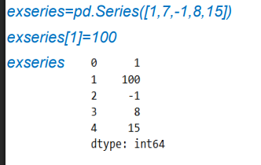
We can consider individual rows and columns of a dataframe as a series:

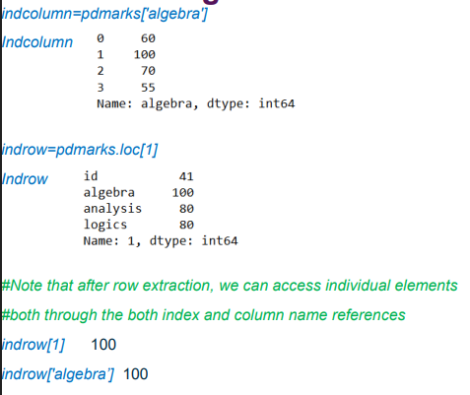
CSV to DataFrame:
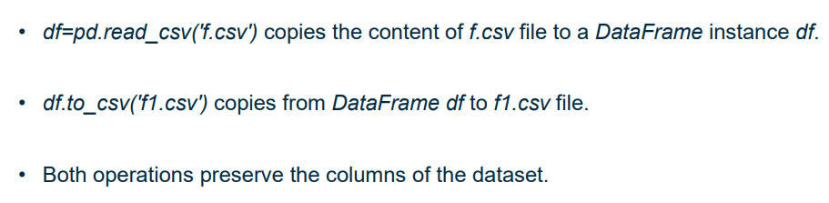
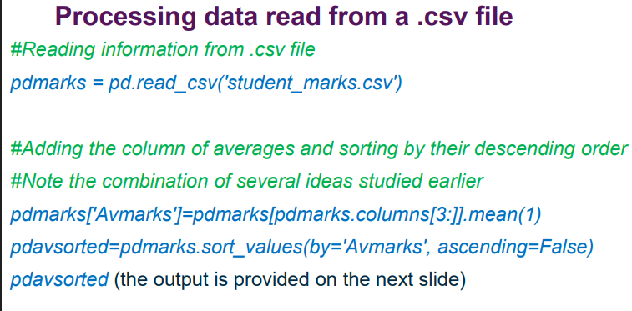
Reading CSV:
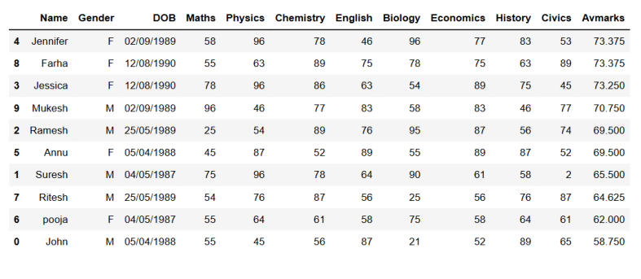
Output:

Excel file to DataFrame:
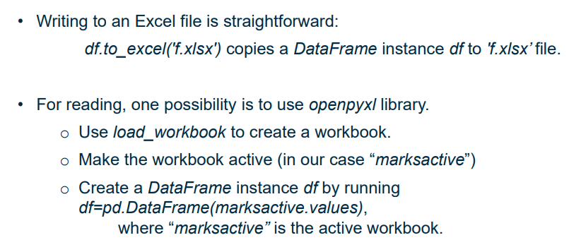

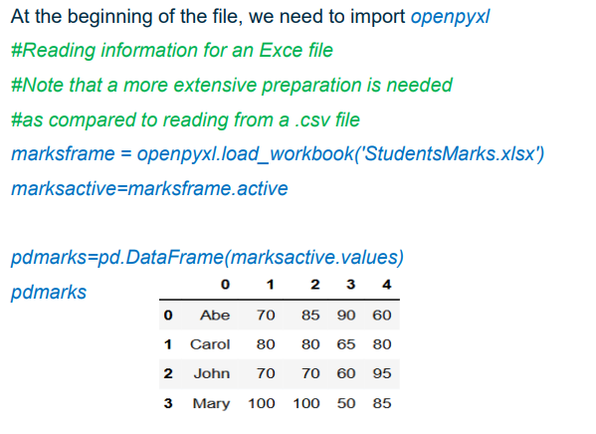
Reading from an Excel file:
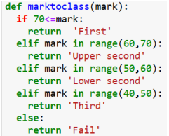
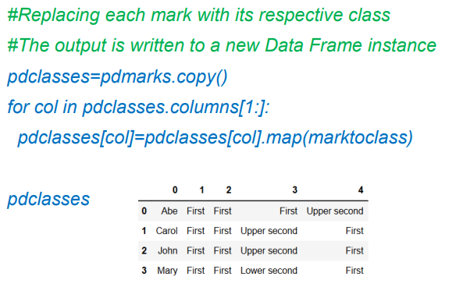
Mapping columns with marks to degree classification:

Pandas and NumPy etc have much redundancy – there are multiple ways of doing a thing, and no single approach is correct.

Data Cleaning and Preparation:
Missing values:
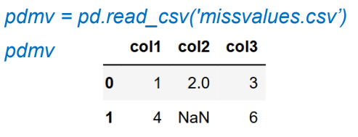
If a DataFrame is read from a csv file where some cells are blank, these will appear in the DF as missing, and will be output as NaN. (this is not the only possible way of missing values occurring).
Handling missing values:
Possible approaches include:
- ignoring the missing values
- dropping either the row or column containing the missing values
- fill missing values with some value that kinda makes sense.
The choice of method depends on the application.

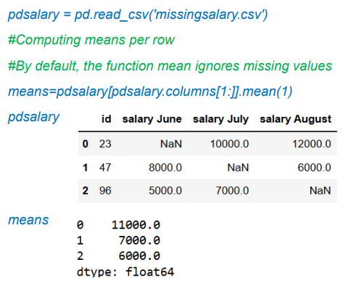
Ignoring missing data can be reasonable:
Especi ally if there are many sporadic missing values, since this will cause a lot of data loss.
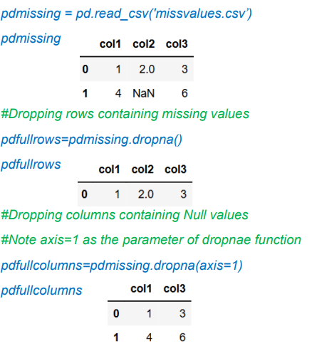
If only a few rows/cols have missing entries, but the number of missing entries in each of these rows/cols is large it would be preferred to drop the rows/cols with missing values.
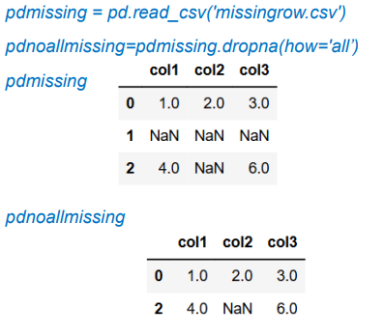
We can also only remove rows where ALL the values are missing:

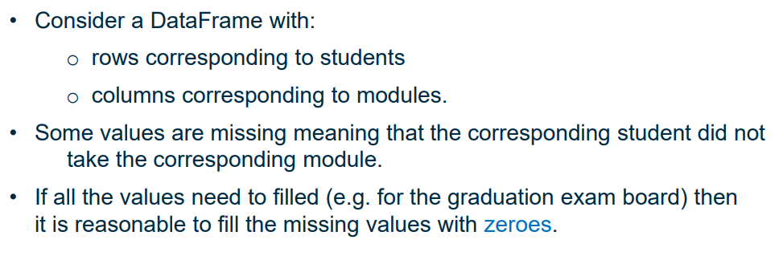
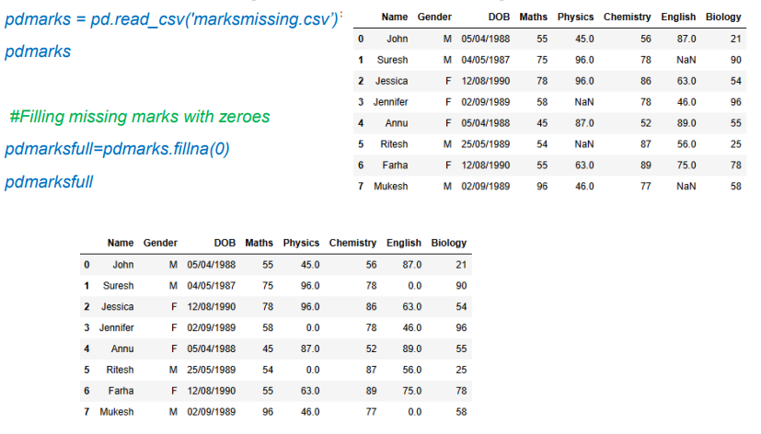
In some cases, filling all missing entries with the same value is appropriate:

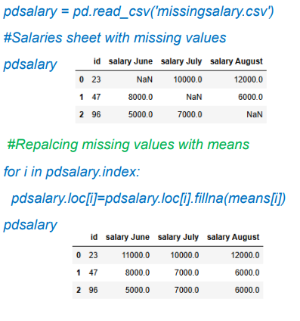
We can also replace the missing values with an average:

Filling forward, e.g. for continuous observations if there is a gap we can use the previous observation to fill the missing value.
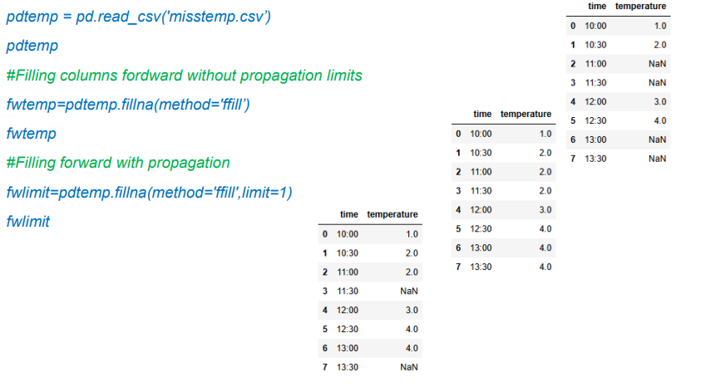
^limit=1 only fills single gaps, if there are multiple consecutive gaps it only fills the first one, and leaves the rest as NaN.
There are other parameters that can be used with the fillna() and dropna() functions in Pandas.

Filling missing values is an important statistical task called imputation. There are better ways of doing it, but these are not needed for this module.
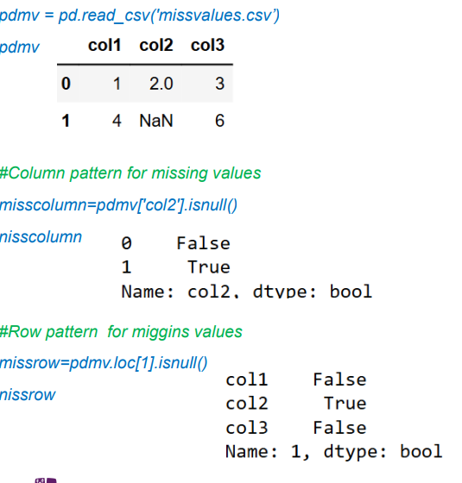
The isnull() function returns a Boolean pattern corresponding to values in a row, with a True entry corresponding to each existing entry in the row and a False entry for each missing entry in the row.
^omg i love miggins

Handling Duplicates:
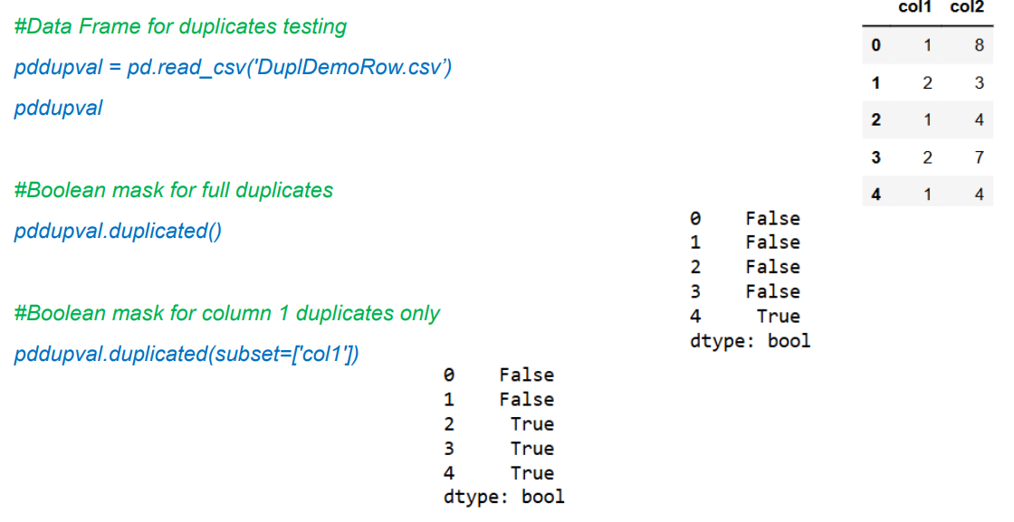
Duplicates in a DataFrame are identical rows. Duplicates may be restricted to a subset of columns (i.e. some columns are the same but others are distinct, but are still considered dupes).
The Pandas duplicated() function returns a Boolean pattern such that any repeated instances of previous rows are True, and unique rows are False. We can use the subset parameter to only consider a subset of the columns.

In some situations, removal of these duplciates may be needed, e.g. duplicate records, but sometimes they need to be kept, e.g. if the repetitions are relevant.
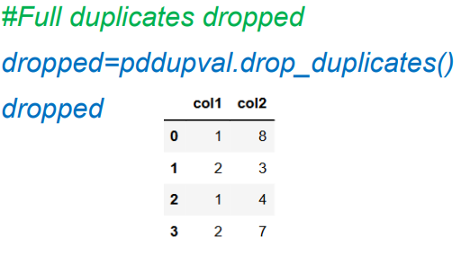
Remove duplicates (uses DF from last screenshot):
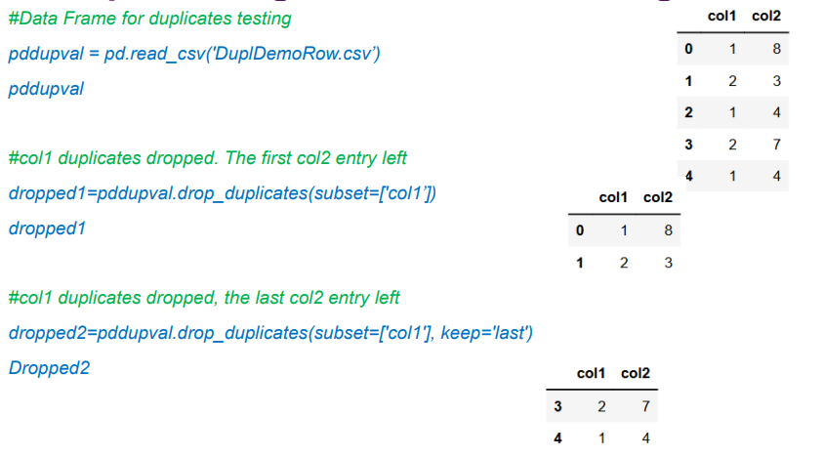
Remove duplicates subject to a subset of columns:
“keep” parameter determines which observation to keep, default is first but we can set it to last – since other columns are distinct that is a difficult decision to make.
More complex functions can be used, making use of the “groupby” function (to be discussed later).

Value_counts() function:
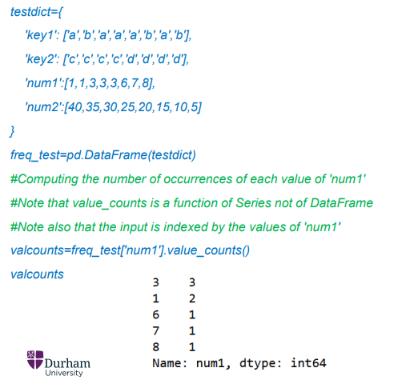
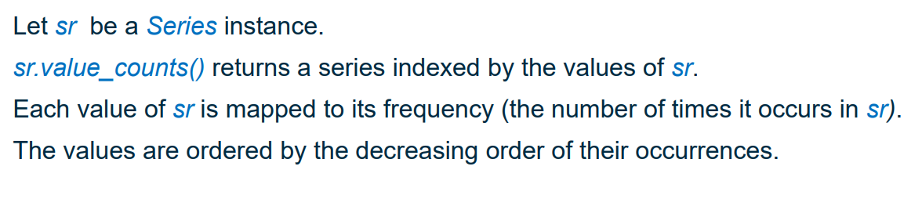
^Series means it can only be applied to a Column in a DF, not a whole DF.
^counts the number of occurrences of a value in a column.
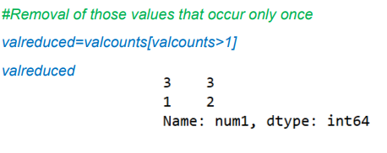
We can use this with a Boolean mask to identify outliers – outliers can be defined as values whose counts are below some threshold number of counts.
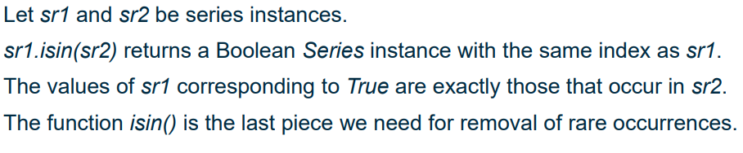
But val_counts() only considers a single column, to update the DF we need to use the “isin()” function.
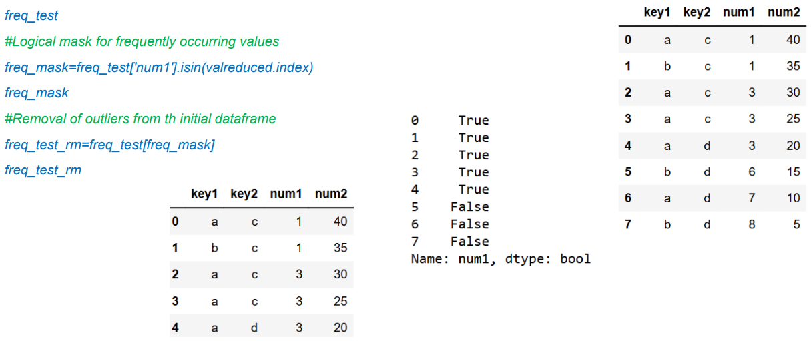
(where valreduced is defined in the previous example for value_counts())

Individual values themselves are often rare, but we can group values into classes and categorise these classes as normal or rare, and then remove the rows corresponding to rare classes.

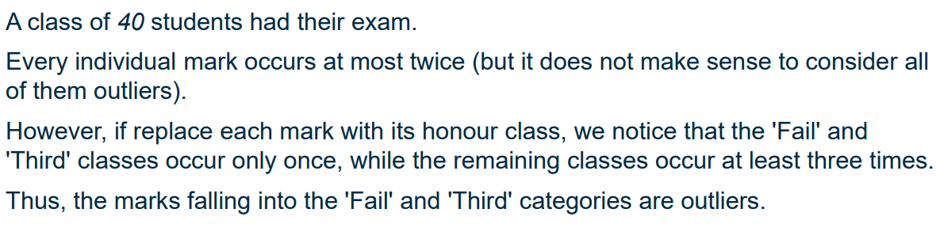
This is because the probability of a continuous random variable taking an individual value is 0, i.e. each individual value is an outlier, so it makes more sense to consider discrete intervals.

Quartile-based removal of outliers:
Quartiles are defined over an ordered sequence of data points S.
Q1: an element x of S is smaller than Q1 iff x belongs to the first 25% of S.
Q2 (median): same but 50%
Q3: 75%.

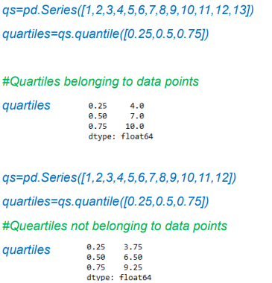
These quartiles can be defined easily in Python:

The Interquartile Range is defined as Q3 – Q1.
We can use this to define what an outlier is:
Lower bound = Q1 – 1.5*IQR
Upper bound = Q3 + 1.5*IQR
Outliers are values outside of these bounds.
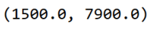
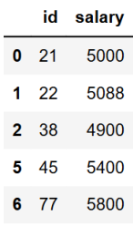
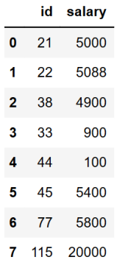
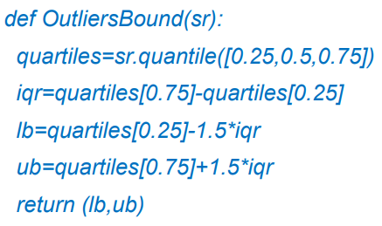
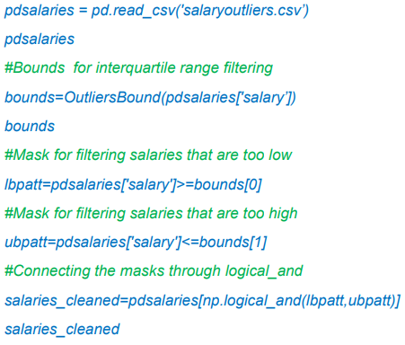
If IQR is small then small values and large values get deleted.
The two methods (deleting rows with infrequent values and using quartiles) are preferable in different applications.

Splitting DataFrames:
It is often important to split a dataset into fragments, where each fragment has the same value for some key. (e.g. splitting salary by gender)
This is performed by the “groupby()” function. This function returns an object of class GroupBy, which cannot be accessed directly – must use a getter function or iterations through it.

To use groupby(), we must identify a key – this determines how the data is fragmented; fragments are created such that all rows in each fragment have the same value of this key.

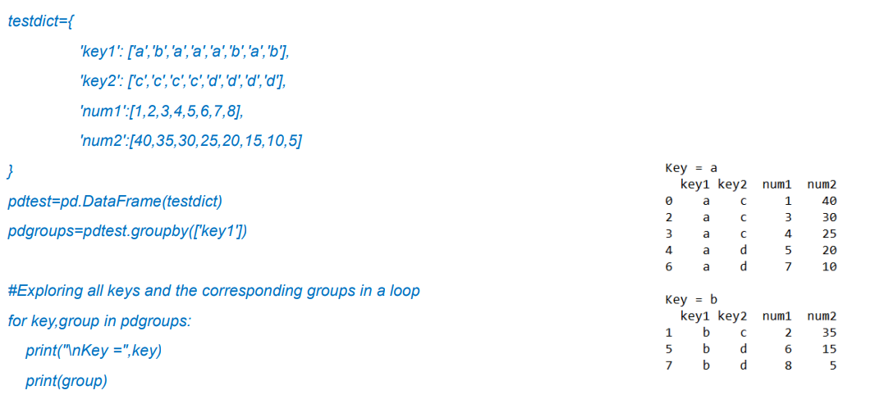
Example using iteration to access the GroupBy object:
^creates 2 groups, one where key1 = a and another where key1 = b.

Using the get_group() function to access a specific group:

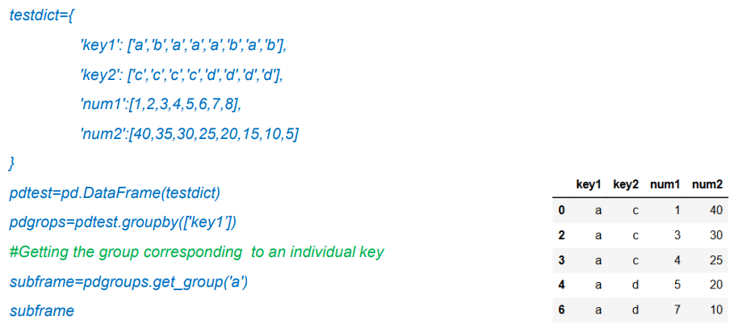
Groupby can be combined with accumulation functions (e.g. sum, mean, min, max) to produce a DF indexed by values of the key. For each key value x, the row in this DF corresponding to x contains the non-key columns of the group where key = x accumulated with the provided function.
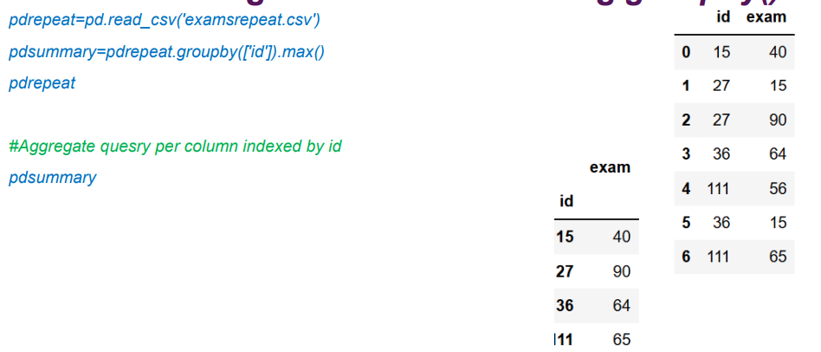
(this is like SQL groupby)

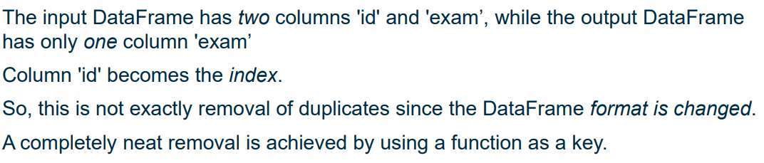
^we don’t want to change the format of the DF

To solve this we can use a function as a groupby key:

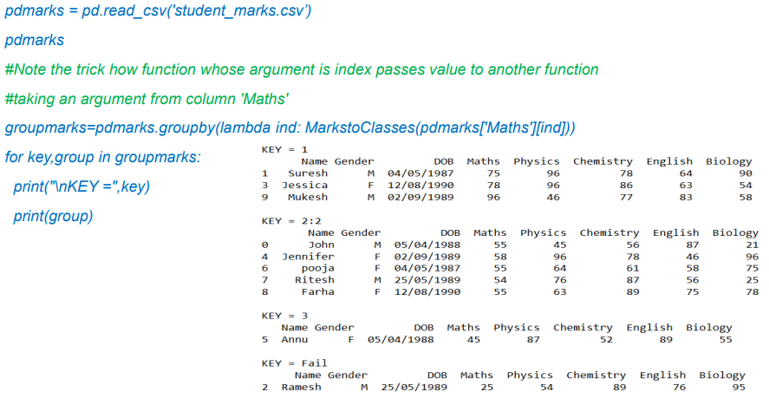
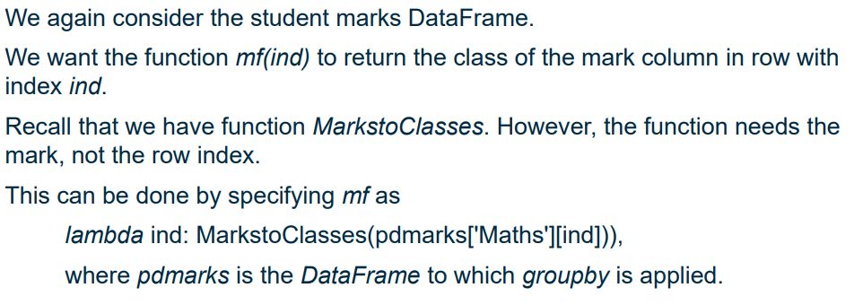
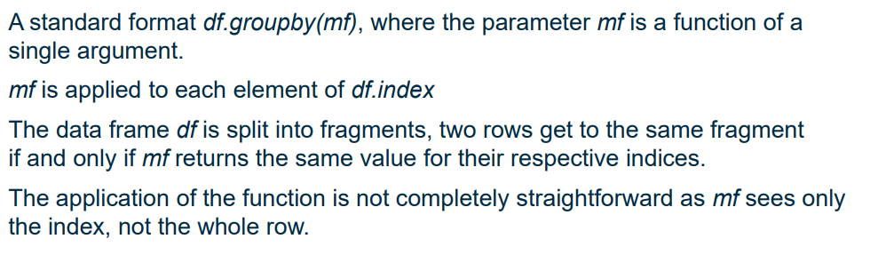
Example:
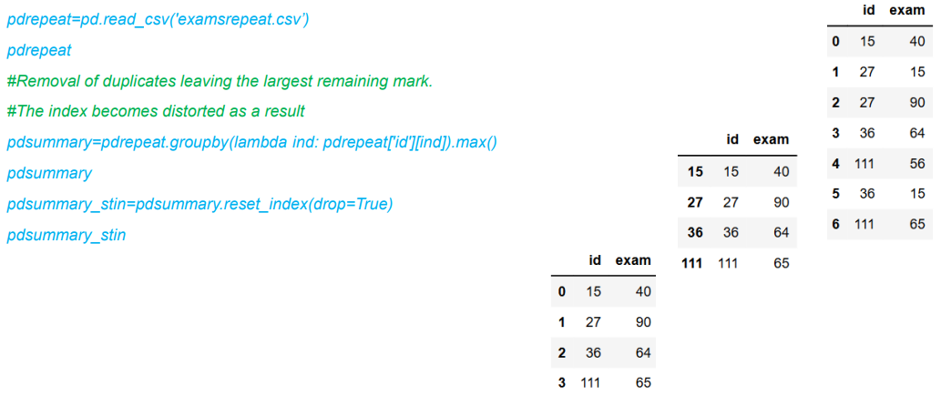
Example: removing duplicates and preserving original DF format
“lambda ind: pdrepeat['id'][ind]” puts the index column back into the pdrepeat DF, but the values are borked so we use reset_index to fix that.

Each column in a DF “df” can be seen as a random variable. For a column “col”, the value of the corresponding variable on row index “x” is “df[col][x]”.
We can use groupby() to determine if these random variables are independent.
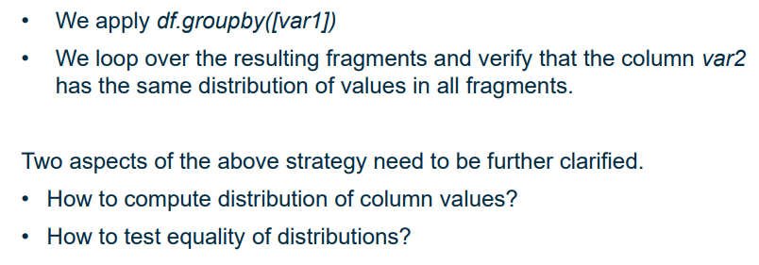
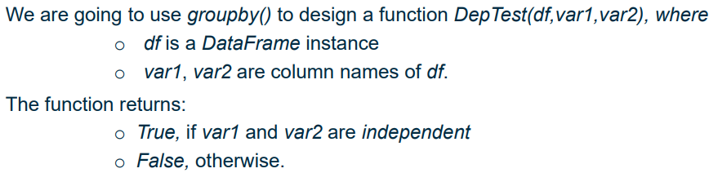
High level overview:

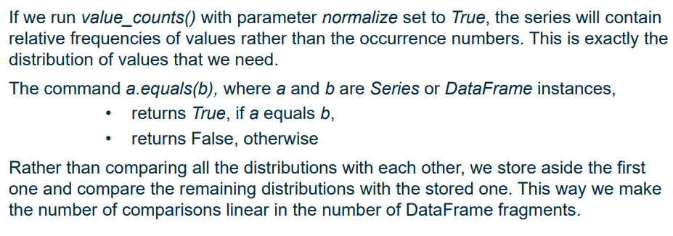
a
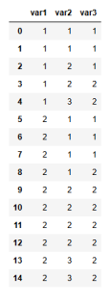
Function Code:
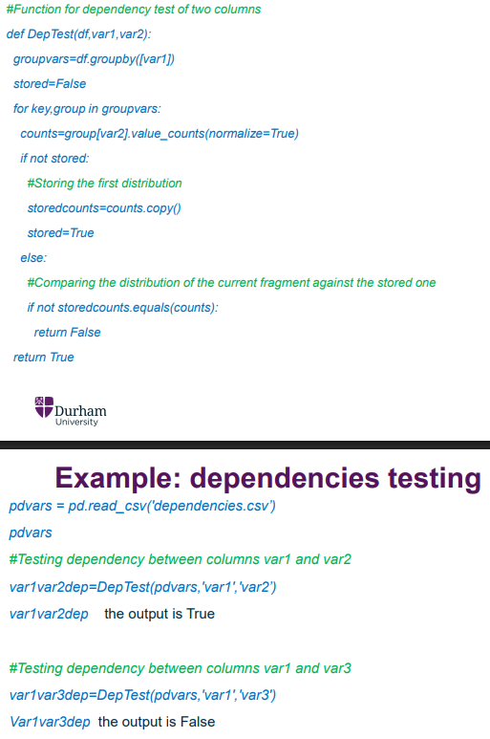
^ checking the distribution of values of var2 for each value of var1. If these distributions are the same for each value of var1, then var1 has no impact on the value of var2v -> independent.

Merging DataFrames:
- like taking a Cartesian product of two sets
The rows of the new DF are all possible combinations of a row of the first DF and the second DF. The merged DFs must have at least one column in common. Two rows concatenate if and only if their respective values in the overlapping columns match.
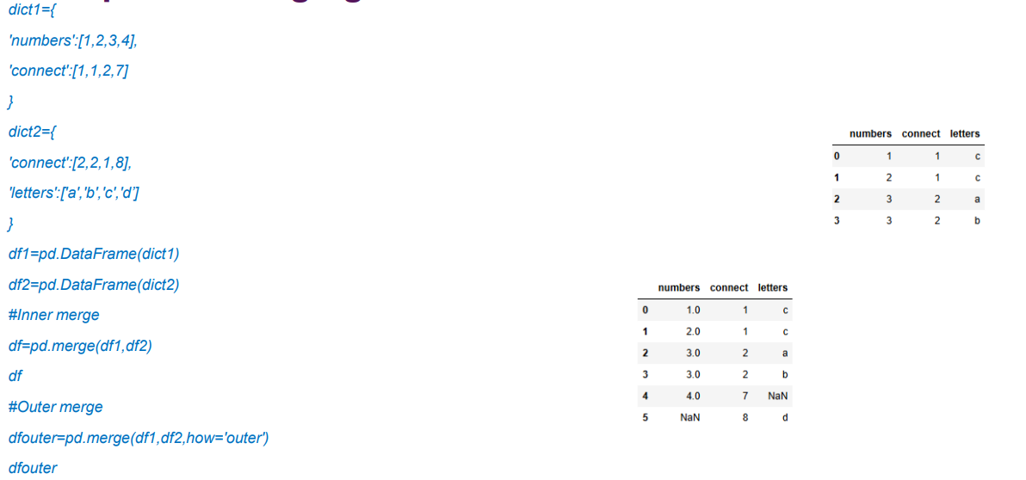
(similar to JOINs in SQL)
^ Outer vs Inner merge (as outer/inner join in databases). For outer merges, NaN is used where values are missing from one of the merged DFs

Note: merging dataframes may result in a DF with a fuckton of data – could be bad. Merging needs to be approached with caution.

Data Visualisation:
One-dimensional data (Series in pandas) can be visualised using a histogram, illustrating number of occurrences or relative frequency for each value occurring. Values can also be grouped into “bins”, with the histogram showing frequencies of each bin rather than the values themselves.

2D data takes the form of a DF with multiple columns. The most basic way of visualising this is scatter graph – can also use box plots and bar graphs.
We can increase dimensions using hues, e.g. using a different colours to represent values of a third attribute. However, too many colours make the diagram less clear and is bad.

Representing high dimensional data:
- no single best way of doing it
We can force it to be 2D, for example by considering the tuples of the first 4 columns to correspond to points on the x axis, and the rest of the columns to be the y axis but this loses the ability to visualise the structures of the columns themselves.
Matplotlib and Seaborn are python libraries for data visualisation.
Matplotlib example:

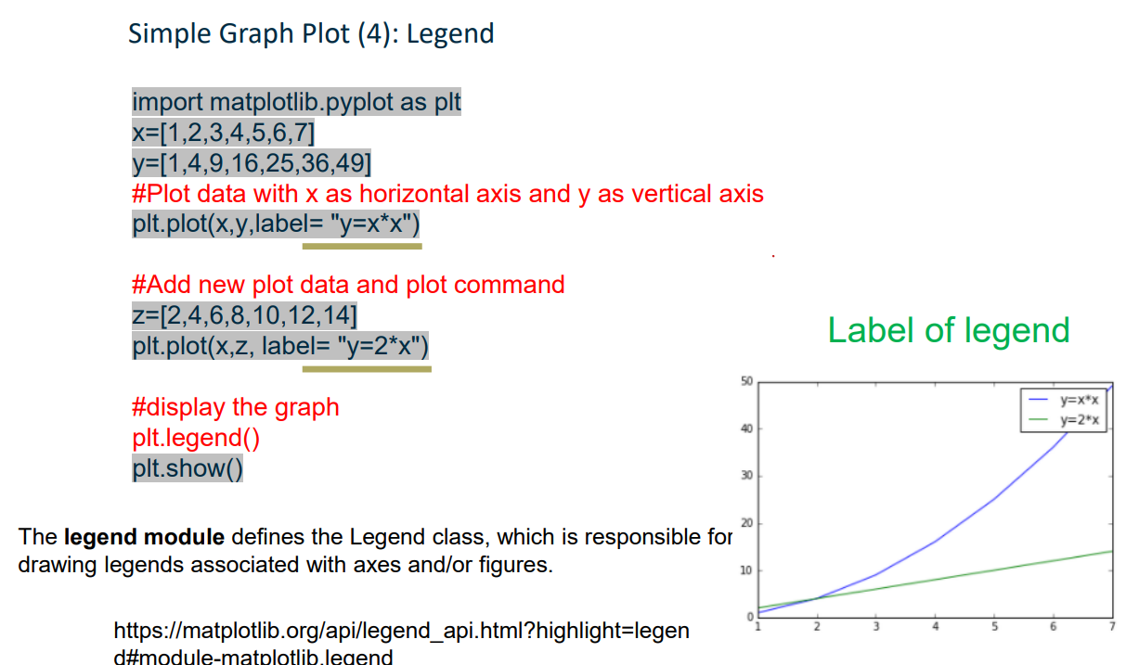
a
Histograms in Seaborn:
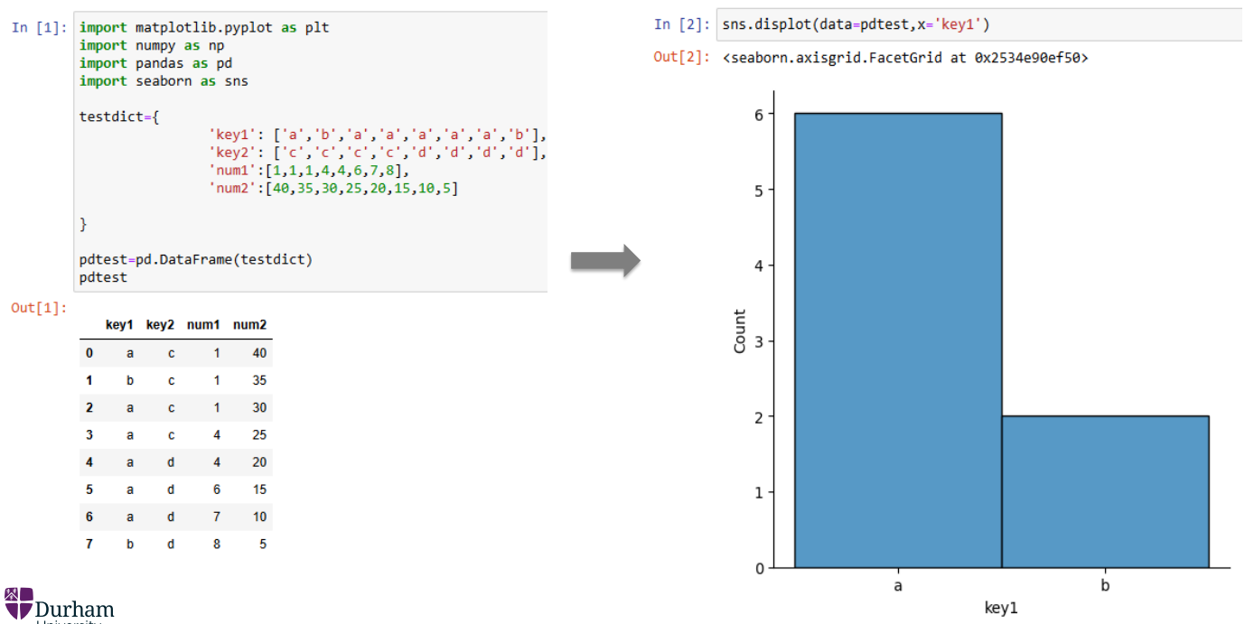
^ literally one command, just need to pass in the DF and the column name used to generate the histogram

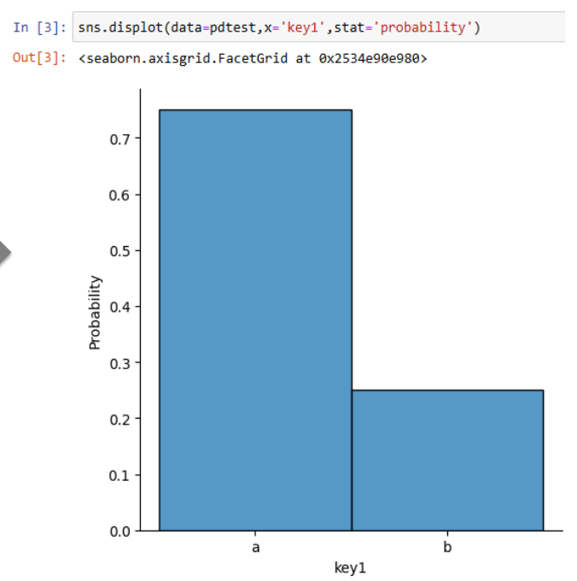
Can also have frequencies on the y axis:

Binning: seaborn partitions a numerical series into intervals or “bins”. The quantities or frequencies are then provided for these bins instead of individual values. Seaborn has a default setting for bins, or:
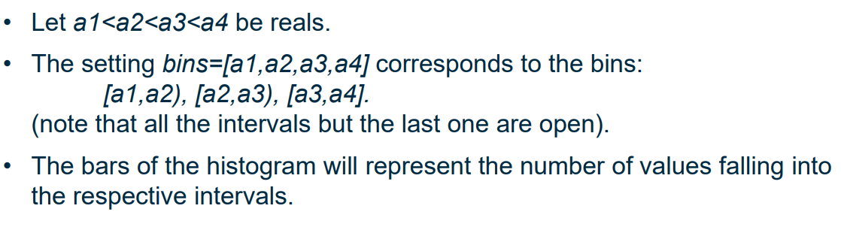
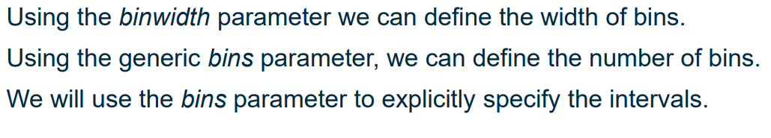
E.g.:
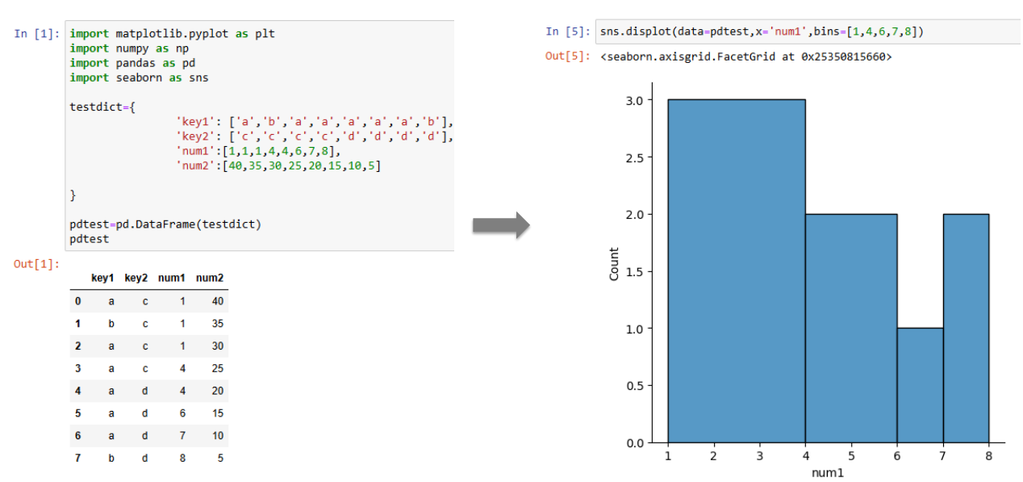
Note: bins can hide information, for example if all values fall into the same bin we achieve fuck all. Bins should be set based on the specific data distribution rather than in general.
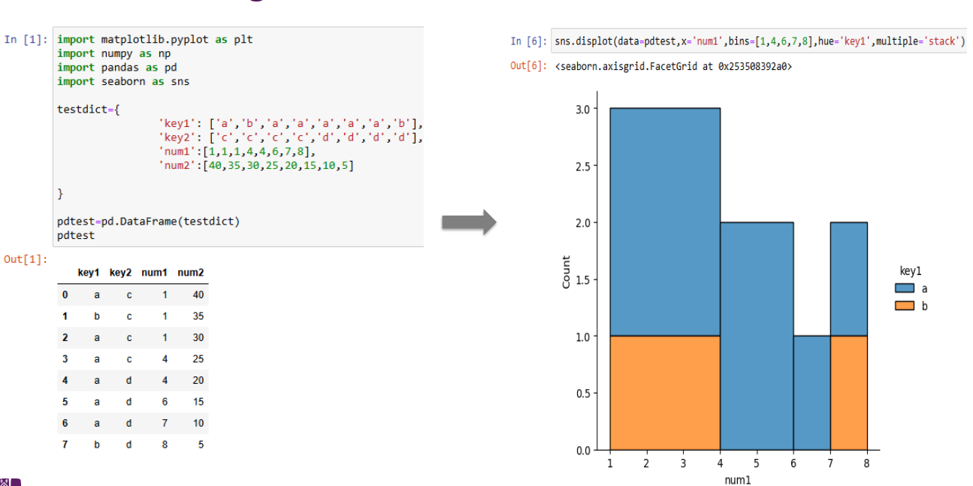
Histograms in stack mode: multiple dimensions
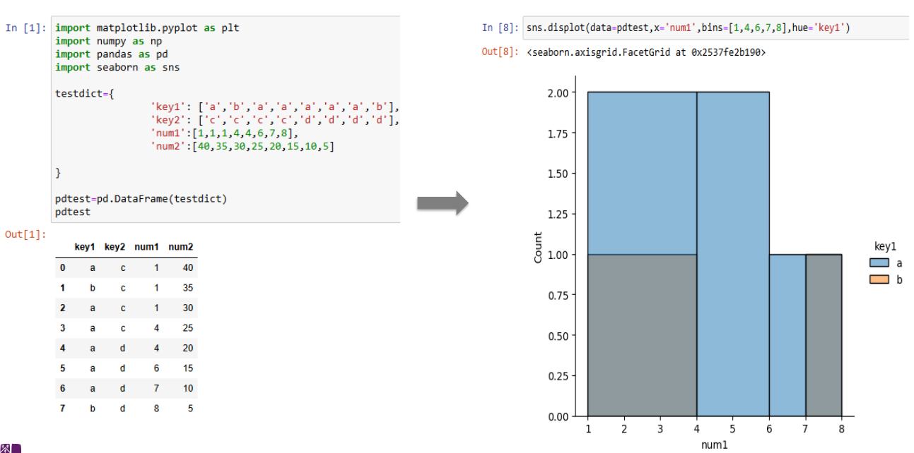
Histogram in layer mode (overlaying columns on top of each other): multiple dimensions 2 electric boolagoo
Note: the colour in the legend doesn’t match because some goofy colour combination shit

If too many columns are passed into “hue” we can get a mess that is unreadable.
We can find the median from a histogram by finding a line that divides the area of the histogram in half. We can use similar techniques to find the quartiles.
Independence from Histograms (kinda):

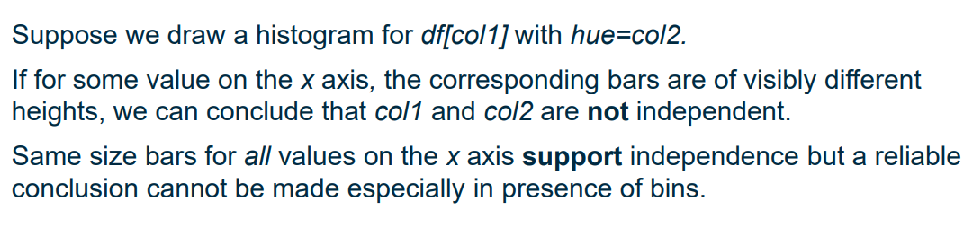
Visualisations for bidimensional data:
Scatter plots:

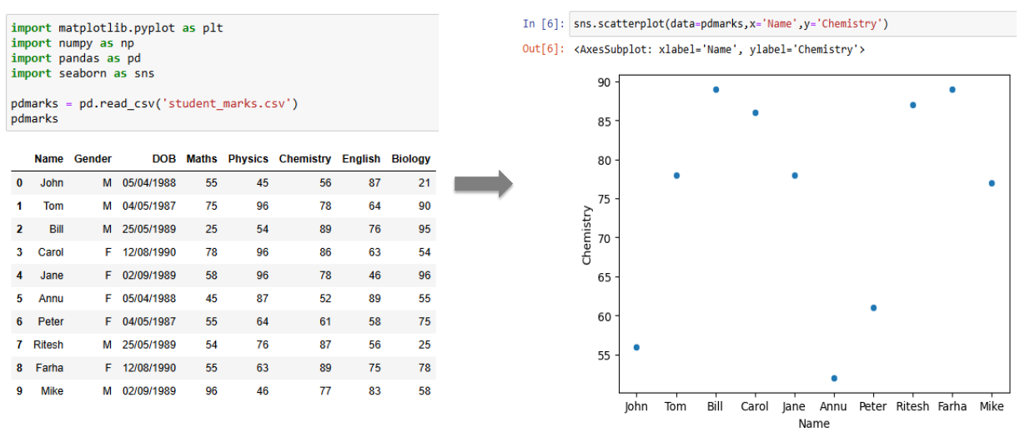
For overlapping points we can present them with a “jitter” effect so they still show as separate points but slightly offset to differentiate between them. A better way of doing it is using a Joint Plot instead of a scatter plot, which combines scatter and histograms:
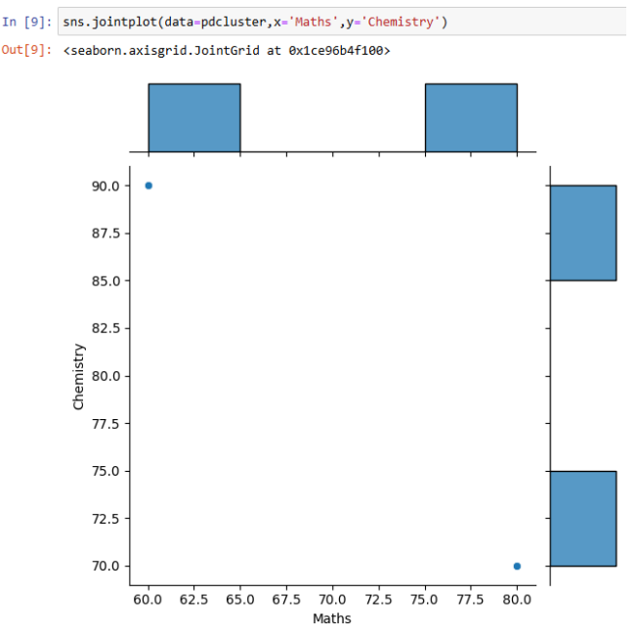
< goofy ahh graph

Scatter plots visualise all the points in a bidimensional distribution. Joint plots also provide information about clustering of overlapping points.

For aggregate statistics (averages etc) should use bar and line plots:
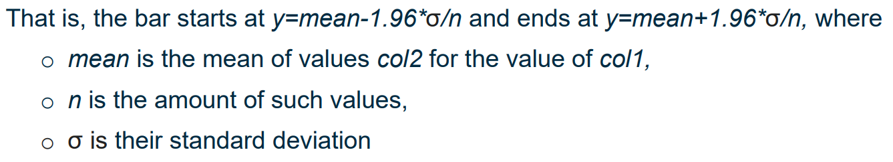
Bar plots visualise two columns, col1 for the x axis and col2 for the y axis. Each value of col1 is associated with a rectangle and error bar. The height of the rectangle represents the aggregate of a statistical measure (e.g. mean) of values of col2. The length of the error bar represents the deviation of the actual set of values from this aggregate. By default, the bar has length 95% of the confidence interval.
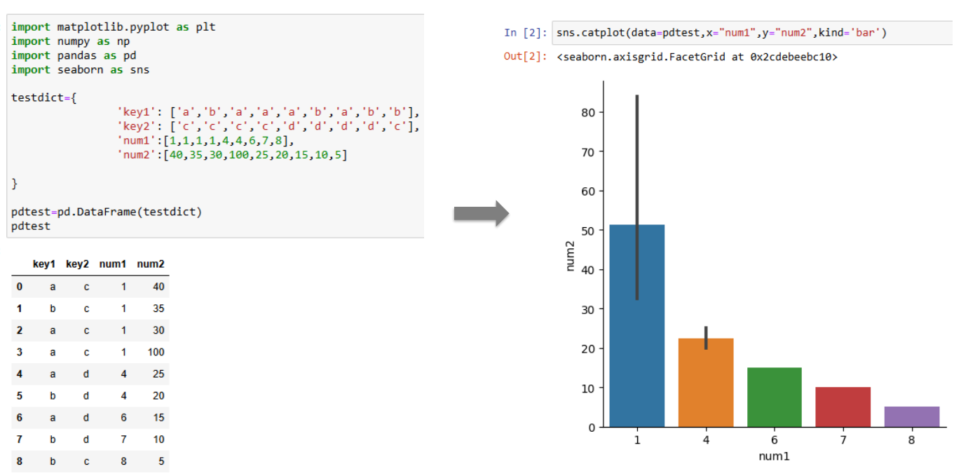
^ no error bar when there's only a single value for num2 for a given num1.
We can use this to visualise averages and whether the values are distributed far from the average, or concentrated close by.
The meaning of bar plots needs to be explained, and are easily confused with histograms.

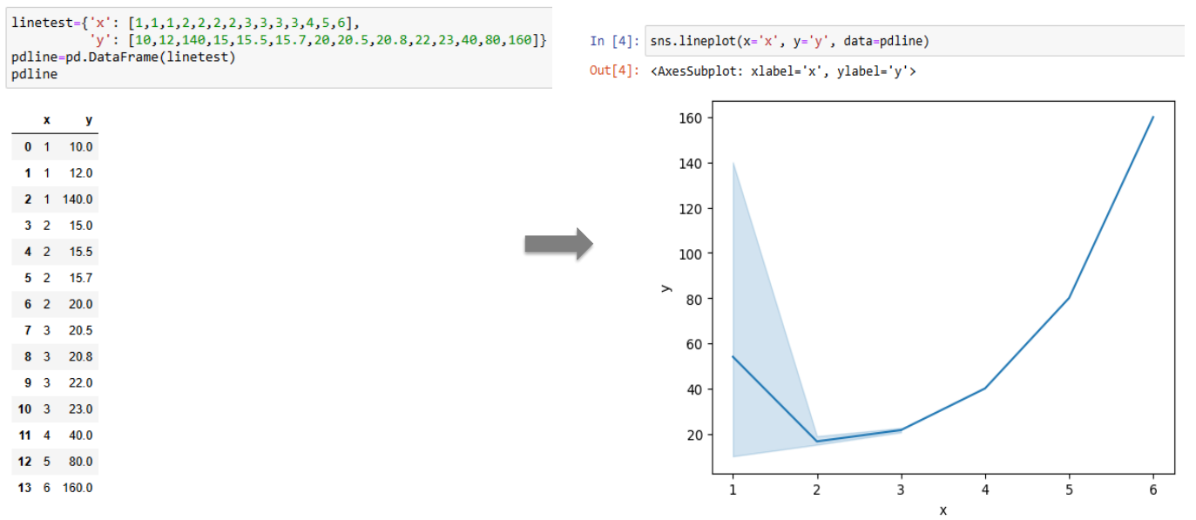
Line plots have x and y axes doing the same thing as bar plots. Line plots specify the points of averages and connect the dots using a curve (interpolation), with shaded regions to demonstrate discrepancy.
Line and bar plots display the same information, but line plots allow the interpolation to be visualised.

High dimensional shit:
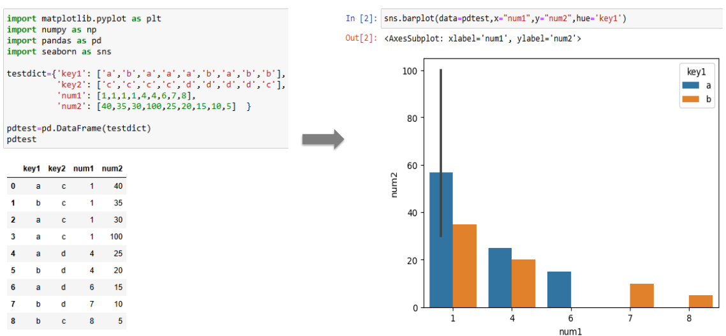
Using different colours: adding more bars per value on the x axis:

Pair-plot: a single picture with relationship between every pair of columns. Uses scatterplots when the cols are different, histograms for individual columns
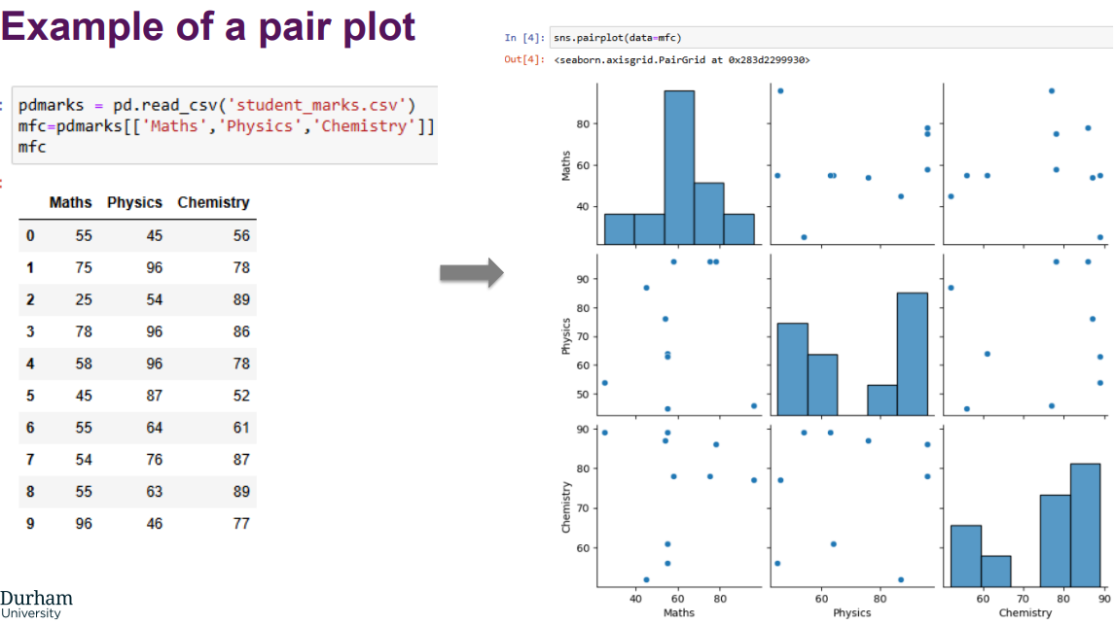
^ bad when we have a fuckton of columns, only considers pairs not higher order relationships.

Heatmaps:
